# SoapUI Document

SoapUI official site document – 2019.5.2 14:05 PM

# SoapUI Projects Window

NOTE: This page contains information on standalone SoapUI Pro that has been replaced with ReadyAPI. To try the new functionality, feel free to download a SoapUI Pro trial from our website.

The project window is opened by double-clicking the project node in the navigator; it contains a number of tabs with project-scoped settings and data:

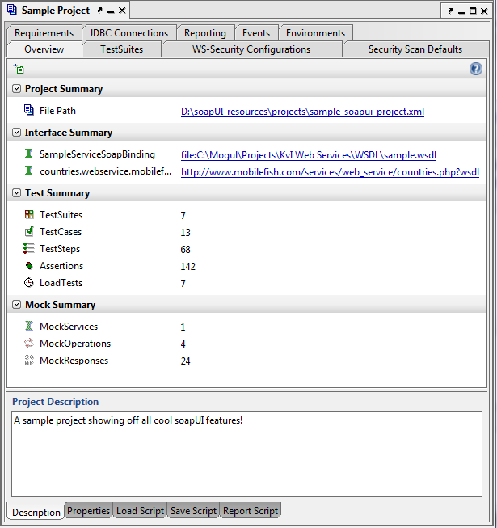

## Overview Tab

The overview tab contains general data on the contained project and allows the specification of a project description, project-level properties and several event scripts that can be used to enrich your project.

|  |  |
| --- | --- |
| **Subtab** | **Contents** |
| Description |  |
| Properties |  |
| Load Script | Called after the project has been loaded. This can be used to for example initiate some session specific data, endpoint, etc. |
| Save Script | Called before the project is being saved, allowing you to perform custom cleanup tasks, for example removing password or test items, etc. |
| Report Script | Called when generating a Project Report |

## TestSuites Tab

Test Suites Tab shows all functional TestSuites in the project (see [link](https://www.soapui.org/Functional-Testing/structuring-and-running-tests.html))

|  |  |
| --- | --- |
| **Subtab** | **Contents** |
| Setup Script | - |
| Teardown Script | - |
| TestSuite Log | - |

## WS-Security Configurations Tab

WS-Security Configurations tab manages project-level WS-Security configuration for SOAP-bases Web Services. (See [link](https://www.soapui.org/SOAP-and-WSDL/applying-ws-security.html))

|  |  |
| --- | --- |
| **Subtab** | **Contents** |
| Outgoing Configurations | - |
| Incoming Configurations | - |
| Keystores | - |
| Truststores | - |

## Security Scan Defaults Tab

The Security Scan Defaults tab contains *Sensitive Information Tokens* for the project.

## Requirements Tab

The Requirements tab manages project requirements. (See [link](https://www.soapui.org/Working-with-Projects/managing-requirements.html))

|  |  |
| --- | --- |
| **Subtab** | **Contents** |
| TestCases | - |
| Links | - |
| Description | - |

## JDBC Connections Tab

The JDBC Connections tab manages project level JDBC connections that can be used in multiple scenarios (See [Link](https://www.soapui.org/Working-with-Projects/jdbc-connections.html)).

## Reporting Tab

| Reporting | manages both global and project-level report templates and parameters(see [Link](https://www.soapui.org/Reporting/reporting-infrastructure.html)).

|  |  |
| --- | --- |
| **Subtab** | **Contents** |
| Available Reports | - |
| Subreports | - |
| Report Details | (Shown for Available reports and Subreports) |
| Templates | - |
| Parameters | - |

## Events tab

The Events tab manages project-level event-handlers that can be used to enhance most aspects of test execution (See [Link](https://www.soapui.org/Scripting-Properties/custom-event-handlers.html)).

## Environments tab

The Environments tab manages project-level environments for easy switching between different sets of SOAP and REST services, properties and data connections (See [Link](https://www.soapui.org/Scripting-Properties/custom-event-handlers.html)).